Filament maker, PLA, PHB, additive technology

Tomáš BALINT, Jozef ŽIVČÁK, Radovan HUDÁK, Marcel ORENIČ

PRODUCTION PROCESS OF MEDICAL POLYMER - PLASTIC BIOPOLYMER

Abstract
This study deals with the production of Plastic Biopolymer, which has never been produced in such a composition of materials. Plastic Biopolymer is intended for medical applications. The filament was produced on Composer 450 filament makers from 3devo. During production, all necessary parameters and thickness of the extruding filament were recorded, which is also described in the graph of this study. Medically certified materials in the form of granules were used for the production. The filament was made of 3 types of polymers PLA, PHB and thermoplastic starch. A 25 percent amount of plasticizer was added to the polymers.

Introduction
When using the filament in additive technologies, it is essential that it meets the requirements necessary for high-quality 3D printing. Desirable properties of the filament include strength, good surface finish and constant diameter. All of these features contribute to the quality of the final print. Biocompatibility and biodegradability are important in medical applications. It is very difficult to produce a suitable medical filament that would meet all these conditions. In this study, however, it was possible after optimizing all the necessary parameters. At the beginning of this study, we made an overview of the market of companies involved in filament extrusion. The addressed companies did not have much experience in the production of medical polymers, which further underlines the complexity of the production of filaments from biodegradable polymers [1] - [4]. We addressed companies such as:

- 3Demon
- Fillamentum
- MAKERSLAB
- MATERIALPRO3D
- 3D PRINT
- NEXEO Plastics
- Innofil 3D

1. FILAMENT PRODUCTION PROCEDURE

The production of the filament is a several-step process (fig. 1) from obtaining the material in the form of granules through drying the granulate in a dryer and the subsequent production process of the filament using a filament maker. After production of the filament, storage under suitable temperature conditions is important to prevent moisture degradation. The filament produced in this way is suitable for 3D printing of objects using FDM technology.

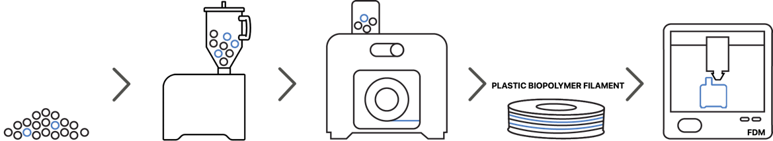

Fig.1. Filamet production process

1.1. Preparation of granules for extrusion

The filament material was supplied in the form of granules, vacuumed in an opaque package to prevent degradation processes. Nevertheless, we dried the material in a dryer from 3devo. Drying parameters are in tab. 1.

Tab.1. Material drying parameters

DRYING TEMPERATURE | 160°C
DRYING TIME | 180 minutes

1.2. Filament extrusion

The production of the filament took place on a filament maker Composer 450 from 3devo under ideal conditions in an air-conditioned room at a temperature of 18 ° C. Before the extrusion, it was necessary to clean the filament maker using HDPE transit material, which has a temperature range of 180 - 280 ° C. After the pre-preparation process, we poured PLA / PHB / thermoplastic starch granules into the hopper. We set the melting point to 170 ° C on the heater 4 and to 171 ° C on other heaters. We reached this temperature by combining knowledge about the melting temperature of PLA / PHB materials. After stabilizing the filament flow, we placed the extruded fiber in a sensor that measured the diameter of the filament. Throughout the production process, the diameter of the filament was in the optimal range. Monitoring and optimization of all production parameters was followed by winding the filament into a spool. The parameters of the production of the Plastic Biolpolymer filament are summarized in tab. 2. For the subsequent use of the filament in additive production, it is important to monitor the diameter of the filament over the extrusion time interval. We managed to maintain the optimal diameter of the filament, as can be seen in fig. 2.

Tab.2. Plastic Biopolymer filament production parameters

HEATER | 4 | 3 | 2 | 1
REAL TEMPERATURE | 170°C | 170°C | 172°C | 171°C
SET TEMPERATURE | 170°C | 171°C | 171°C | 171°C
SCREW SPEED | 2.0 RPM
FAN POWER | 80%

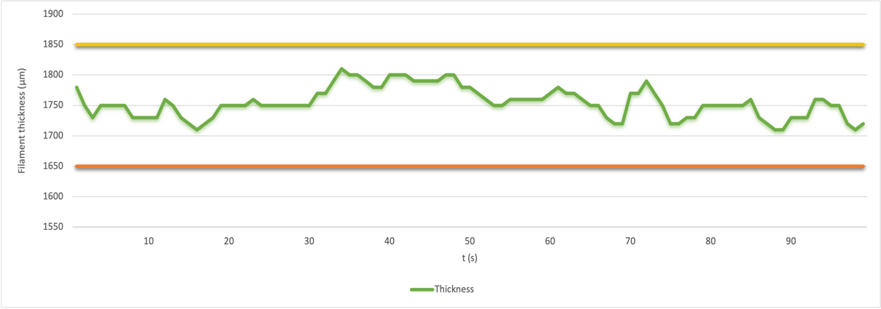

Fig.2. Graph of the course of the filament diameter over time (t)

The parameters (tab. 3) and the resulting filament (fig. 3) are the output of the filament production process.

Tab.3. Parameters of the produced filament - Plastic Biopolymer

FILAMENT DIAMETER | 1,75mm
FILAMENT WEIGHT | 410,13g

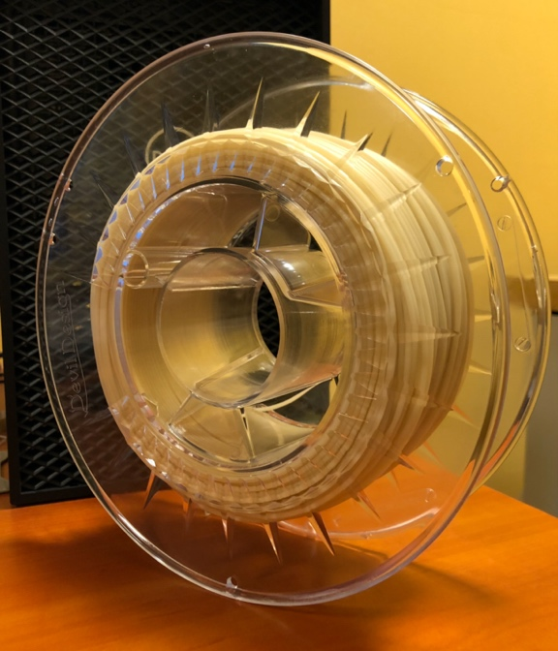

Fig.3. Finished filament - Plastic Biopolymer
Conclusion

This scientific study is the theoretical output of the production of Plastic Biopolymer filament, which is intended for medical applications. The filament was made from PLA / PHB / thermoplastic starch granules with the addition of 25% plasticizer. By monitoring all parameters and optimizing, we were able to produce a filament with a constant diameter of 1.75 mm along the entire length of the filament, which contributes to the excellent quality of the product made by additive technology in the future. With the Composer 450 from 3devo company, located in the Department of Biomedical Engineering and Measurement, we have achieved results that have a significant contribution to the production, testing and usage of medically certified materials.

Acknowledgements
This publication is the result of the project implementation: „Open scientific Integrated Infrastructure for the project: Center for Medical Bioadditive Research and Production (CEMBAM), code ITMS2014 +: 313011V358, supported by the Operational Programme Integrated Infrastructure, funded by the ERDF“ and with the support of KEGA 040TUKE-4/2019 digitization methods to support the educational process in the field of aortotic prosthetics) and also by project VEGA 1/0179/19 Development and construction of low-cost modular prostheses of upper limbs manufactured by additive technologies.

References

[1] MIRÓN, V., FERRÁNDIZ, F., JUÁREZ, D., MENGUEL, A.: Manufacturing and characterization of 3D printer filament using tailoring materials. Procedia manufacturing. 2017. Available on the internet: https://www.sciencedirect.com/science/article/pii/S2351978917307886

[2] Çanti, E., Aydın, M., Yıldırım, F.: Production and Characterization of Composite Filaments for 3D Printing. Journal of Polytechnic. 2018. Available on the internet: https://www.researchgate.net/publication/322903568_Production_and_Characterization_of_Composite_Filaments_for_3D_Printing

[3] Mikula, K., Skrzypczak, D., Izydorczyk, G., Warchoł, J., Moustakas, K., Chojnacka, K., Witek-Krowiak, A.: 3D printing filament as a second life of waste plastics - a review. Environmental Science and Pollution Research. 2020. Available on the internet: https://link.springer.com/article/10.1007/s11356-020-10657-8

[4] Balint, T., Balogová, A., F., Hudák, R., Živčák, J., Schnitzer, M., Feranc, J.: Production, additive printing and mechanical testing of PLA/PHB material with different concentrations of TAC emollient. 19th World Symposium on Applied Machine Intelligence and Informatics (SAMI). 2021. Available on the internet: https://www.researchgate.net/publication/350301053_Production_additive_printing_and_mechanical_testing_of_PLAPHB_material_with_different_concentrations_of_TAC_emollient

Ing. Tomáš Balint, Faculty of mechanical engineering TUKE, Letná 9, Košice, tomas.balint@tuke.sk
Dr. h. c. mult. prof. Ing. Jozef Živčák, PhD., MPH, Faculty of mechanical engineering TUKE, Letná 9, Košice, jozef.zivcak@tuke.sk
prof. Ing. Radovan Hudák, PhD., Faculty of mechanical engineering TUKE, Letná 9, Košice, radovan.hudak@tuke.sk
PhDr. Marcel Orenič, Faculty of Public Administration UPJŠ, Popradská 66, Košice, marcel.orenic@student.upjs.sk

